
LA GRANDEE INTERNATIONAL COLLEGE
Simalchaur, Pokhara Nepal
A Final Report
On
“Study-Buddy”
Submitted to:
Bachelor of Computer Application (BCA) Program
In Partial fulfilment of the requirements of the degree of BCA under Pokhara Unviersity
Submitted by:
Name: | Course: | Semester: | P.U. Registration:
Depika Kumari Sharma | BCA | 4th | 2024-1-53-0164
Sampada Pahari | BCA | 4th | 2024-1-53-0184
Prasid Gautam | BCA | 4th | 2024-1-53-0174

Date: 12th July 2026

Student Declaration
We hereby declare that we are the only authors of this work and that no sources other than the listed here have been using in this work. We assure you that the work we present here is unique to ourselves and likenesses to another similar project are purely coincidental.
Student Name 1 (Roll No: XXXXX)
Depika Kumari Sharma (2024-1-53-0164)
Sampada Pahari (2024-1-53-0184)
Prasid Gautam (2024-1-53-0174)
Program: Bachelor of Computer Application
Semester: 4th Semester
Date: 12/07/2026

Supervisor's Declaration
I hereby recommend that the project entitled Study-Buddy done under my supervision by Depika Kumari Sharma, Sampada Pahari and Prasid Gautam during their 4th semester in partial fulfillment of the requirement for the degree of Bachelor of Computer Application (BCA) under affiliation of Pokhara University is completed to my satisfaction and be processed for final evaluation.

Mr. Suman Devkota
Supervisor
Date:



Approval Certificate
We certify that we have examined this report entitled “Study-Buddy” and are satisfied with the project defense. In our opinion, it is satisfactory in the scope and qualify as project in partial fulfilment of the requirements for the degree of BCA under Pokhara University.

___________________ ___________________ ___________________
Ankit Poudyal Er. Bibit Kunwar Chhetri Er. Kiran K.C
Program Coordinator External Examiner Principal

ACKNOWLEDGEMENT
We are grateful to our project supervisor Mr. Suman Devkota and our BCA coordinator Mr.Ankit Poudyal for the guidance, inspiration and constructive suggestions that helped us in the preparation of this project.
We are also appreciative among each other and understood the teamwork, the designation of the task per the skillset one represents constant synchronisation and monitoring of progress and introducing new knowledge and skill is commanding for the success of any given work.
Sincerely,
Depika Kumari Sharma
Sampada Pahari
Prasid Gautam

Abstract
Study-Buddy is a desktop-based academic resource sharing system developed to improve access to educational materials among students. Many students face difficulties in obtaining lecture notes, assignments, past examination papers, and other study resources due to the lack of an organized platform. Existing methods such as social media groups and messaging applications often result in inefficient resource management and poor accessibility.
The proposed system provides a structured environment where students can upload, search, download, and request academic materials. A dedicated Request Board feature enables users to post requests for specific study resources, allowing other students to contribute and support collaborative learning. The system also includes user authentication, resource categorization, search and filter functionality, comment mechanisms, and administrative controls for managing users and content.
The application is developed using Java for the graphical user interface and application logic, while Microsoft SQL Server is used for database management and secure data storage. The system aims to provide an efficient, secure, and user-friendly platform that enhances resource accessibility, encourages knowledge sharing, and improves the overall learning experience for students.
Keywords: Academic Resource Sharing, Collaborative Learning, Java, MS SQL Server, Request Board, Study Materials Management.

Table Of Contents
1. Introduction 1
1.1. Background 1
1.2. Objectives 1
1.3. Aim, Scope and Applicability 2
1.3.1. Aim 2
1.3.2. Scope 2
1.3.3. Applicability 2
1.4. Achievements 2
1.5. Organization of Report 2
2. Survey of Technologies 3
2.2 Review of Existing Systems 3
2.2.1 Sakai Learning Management System 3
2.2.2 OpenOLAT 4
2.2.3 Google Classroom 5
2.3 Comparison of Existing Systems 5
3. Requirements and Analysis 6
3.1 Problem Definition 6
3.2 Requirement Specification 6
3.2.1 Functional Requirements 6
3.3.2 Non-Functional Requirements 7
3.3 Planning and Scheduling 8
3.4 Hardware and Software Requirements 9
3.5 Preliminary Product Description 10
3.6 Conceptual Models 11
3.6.1 Context Diagram (Level 0 DFD) 11
3.6.2 Use Case Diagram 12
3.6.3 Entity-Relationship (ER) Diagram 12
3.6.3 Entity-Relationship (ER) Diagram 13
4. Design 14
4.1 Introduction 14
4.2 System Design 14
4.3 Database Design 15
4.3.1 User Table 15
4.3.2 Notes Table 16
4.3.3 Request Board (Ask QN) Table 16
4.3.4 Category Table 16
4.4 Interface Design 17
4.5 Summary 18
5. IMPLEMENTATION AND TESTING 19
5.1. Implementation Approaches 19
5.2 Coding Details 19
5.2.1 Code Efficiency 20
5.3 Testing Approach 21
5.3.1 Unit Testing 21
5.3.2 Integrated Testing 22
5.3.3 Beta Testing 22
5.4 Modifications and Improvements 22
5.5 Test Cases 23
5.6 Verification and Validation 26
6. RESULTS AND DISCUSSION 27
6.1 Test Reports 27
6.2 User Documentation 28
7. Conclusion 31
7.1. Conclusion 31
7.2. Significance of the System 31
7.3 Limitations of the System 32
7.4 Future Scope 32
8. Reference 34

List Of Figure
Figure 3-3: Gantt Chart 9
Figure 3.6.1: Context Diagram 11
Figure 3.6.2: Use Case Diagram 12
Figure 3.6.3: ER Diagram 13

List of Tables
Table 2.3. 1 Comparison of existing systems 5
Table 3.4. 1: Development Environment 10
Table 3.4. 2: Client Environment 10
Table 4.3.1: User Table 15
Table 4.3.2: Notes Table 16
Table 4.3.3: Request Board Table 16
Table 4.3.4: Category Table 16
Table 5.1: Technologies used while Implementation 19
Table 5.3.2. 1:Integrated Testing 22
Table 5.4. 1:Modifications 23
Table 5.5. 1: Test Cases 23
Table 6.1 1: Modules and their Status 27

List of Abbreviations
CRUD | Create, Read, Update and Delete
DFD | Data Flow Diagram
MS SQL Server | Microsoft SQL Server
UI | User Interface

Introduction

1.1. Background
In the modern digital learning environment, students often face difficulties in finding reliable academic resources such as lecture notes, past examination papers, assignments, and study materials. Many students depend on informal platforms like social media groups and messaging applications for sharing educational content, but these methods are usually unorganized, time-consuming, and inefficient. Due to the lack of a centralized and structured platform, students may struggle to access the required materials when needed.
To address these problems, the proposed project “Study-Buddy” is developed as a desktop-based academic resource sharing system. The system will provide a structured and user-friendly platform where students will be able to upload, search, download, and request academic materials easily. One of the major features of the system will be the Request Board, through which students will be able to post requests for specific study resources, allowing other users to contribute and help fulfill those requests. The system will also promote collaboration and knowledge sharing among students in an organized manner.
The application will be developed using Java for implementing the application logic and graphical user interface, while Microsoft SQL Server (MS SQL Server) will be used for database management and secure storage of user and resource information. The project will focus on creating a secure, efficient, and easy-to-use environment that will improve accessibility to academic resources and support collaborative learning among students.

1.2. Objectives
The primary goal is to develop a functional, user-friendly software application that meets the following specific objectives:
- To develop a structured platform for sharing and accessing study materials easily.
- To allow students to request and provide specific academic content.
- To make learning resources easily searchable and well-organized.

1.3. Aim, Scope and Applicability

1.3.1. Aim
- Action-oriented academic hub
- Study-material management
- Make organized academic

1.3.2. Scope
- User management system
- Study resource sharing
- Request and upload feature
- Search and organize materials

Applicability
Study-Buddy is applicable to:
- School students
- College and university students

1.4. Achievements
- Successfully designed and implemented a functional Study-Buddy system
- Created an intuitive and user-friendly interface
- Tested the system for functionality and performance

1.5. Organization of Report
This report is organized into seven chapters covering introduction, technology survey, system analysis, design, implementation and testing, results, and conclusions.

Survey of Technologies
2.1 Introduction
The rapid advancement of information technology has transformed the education sector by enabling digital learning and efficient sharing of academic resources. Students increasingly depend on digital platforms to access lecture notes, assignments, presentations, previous examination papers, and other learning materials. Although many learning management systems are available, they are often designed for complete institutional management rather than simple student-to-student resource sharing.
Study-Buddy is developed to overcome these limitations by providing a lightweight desktop-based academic resource sharing platform where students can upload, search, download, and request study materials in an organized manner. Before designing the proposed system, several existing learning platforms and academic resource management systems were studied to understand their strengths, weaknesses, and limitations.

2.2 Review of Existing Systems

2.2.1 Sakai Learning Management System
Sakai is an open-source Learning Management System developed primarily for higher education institutions. It supports online learning, assignment submission, course management and assessment. (www.sakailms.org, 2023).
Key Features:
- Course management
- Content sharing
- Assignment submission
Strengths:
- Highly scalable and suitable for large institutions
- Open-source and customizable
- Supports multiple users
Weaknesses:
- Not suitable for small student communities
- Requires server deployment
- User interface is less intuitive
Relevance to Study-Buddy
Study-Buddy adopts the concept of centralized academic resource management but focuses on simplicity and collaborative resource sharing rather than complete institutional course management.

2.2.2 OpenOLAT
OpenOLAT is a Java-based open-source e-learning platform widely used in universities and training organizations (Wikipedia Foundation Inc, 14). It focuses on structured learning and assessment (www.openolat.com, 2024).
Key Features:
- Online Courses
- Assessments
- Progress Tracking
Strengths:
- Flexible course management
- Good performance
- Supports many users
Weaknesses:
- Less focused on direct student resource sharing
- Difficult for beginners
Relevance to Study-Buddy
Study-Buddy incorporates collaborative learning concepts from OpenOLAT while providing a much simpler interface specifically designed for sharing study resources.

2.2.3 Google Classroom
Google Classroom is a cloud-based educational platform developed by Google that allows teachers to create classes, distribute assignments, and communicate with students.
Strengths:
- Google integration
- Easy to use
Weaknesses:
- Requires internet connection
- Mainly teacher-centered
- No dedicated Request Board for academic materials
Relevance to Study-Buddy
Unlike Google Classroom, Study-Buddy encourages peer-to-peer resource sharing and allows students to request missing study materials through a dedicated Request Board.

2.3 Comparison of Existing Systems
Table 2.3. 1 Comparison of existing systems
Feature | Sakai | OpenOLAT | Google Classroom | Study-Buddy
Desktop Application | No | No | No | Yes
Resource Upload | Yes | Yes | Yes | Yes
Resource Download | Yes | Yes | Yes | Yes
Request Board | No | No | No | Yes
Search Resources | Yes | Yes | Limited | Yes
Resource Categories | Yes | Yes | Limited | Yes
Admin Panel | Yes | Yes | Yes | Yes

3. Requirements and Analysis

3.1 Problem Definition
Students frequently rely on social media platforms, messaging applications, and cloud storage services to exchange study materials. These methods are often unorganized, making it difficult to locate specific resources, avoid duplicate uploads, or verify the quality of shared content. Existing learning management systems mainly support teacher-to-student content distribution and provide limited support for peer-to-peer resource sharing.
The absence of a centralized academic resource sharing platform creates several challenges:
- Difficulty locating study materials.
- No organized categorization.
- Lack of request mechanism.
- Limited resource management.
- Time-consuming searching process.
Study-Buddy addresses these challenges by providing a centralized desktop application for uploading, organizing, searching, downloading, and requesting academic resources.

3.2 Requirement Specification

3.2.1 Functional Requirements
1. User Authentication & Profiles
- Register users with email and password
- Login users securely into the system
- Create and manage user profiles
- Store passwords in encrypted form
2. Upload & Resource Management
- Upload study materials (notes, assignments, past papers)
- Add subject and course details
- Search and download resources
- Preview available materials
3. Request Board
- Post requests for specific study materials
- Add subject and description in requests
- Respond to requests by uploading resources
4. Search & Filters
- Search resources using keywords or subjects
- Filter resources by category or type
- Sort results for easy access
5. Resource Interaction
- View and download study materials
- Give comments resources
- Identify useful content through ratings.
6. Admin Management
- Manage users and uploaded content
- Remove invalid or duplicate resources
- Monitor system activities

3.3.2 Non-Functional Requirements
1. Performance
- Ensure fast search and response time
- Support smooth system operation
2. Security
- Secure user login system
- Restrict access based on user roles
3. Usability
- Design simple and user-friendly interface
- Provide easy navigation for all features
4. Reliability
- Maintain accurate and consistent data
- Data Consistency
- Error Recovery
5. Maintainability
- Develop modular and well-structured code
- Allow easy updates and modifications

3.3 Planning and Scheduling
The Study-Buddy project followed the Agile Software Development Model. The project was divided into iterative phases to ensure continuous development, testing, and improvement.The project timeline is structured into three sequential sprints (S1, S2, and S3) over a 10-week period. Rather than traditional sequential phases, this schedule utilizes an iterative pipeline where each sprint delivers fully functional, tested, and shippable increments.
Each of the three sprint cycles follows an identical internal execution workflow:
- Planning (Start of Sprint): A brief, highly focused phase at the initiation of the sprint to define the sprint backlog and goals.
- Development (Weeks 1–2 of the Sprint): The heaviest phase where the core implementation and coding of the sprint's specific features take place.
- Testing (Week 2–3 of the Sprint): Overlapping slightly with the end of development, this phase involves rigorous unit and integration testing to catch bugs early.
- Review / Retro (End of Sprint): A collaborative session to demonstrate the working increment to stakeholders and evaluate team performance.
- Features Shipped (Sprint Milestone): The final deployment step where completed features are successfully delivered to production or a staging environment.

Figure 3-3: Gantt Chart

3.4 Hardware and Software Requirements
Development Environment
Table 3.4. 1: Development Environment
Components | Specification
Processor | Intel Core i5 or higher
RAM | 8 GB
Storage | 256GB SSD
Operating System | Windows 10/11
IDE | IntelliJ IDEA
Language | Java
GUI | JavaFX
Database | Microsoft SQL Server
Database Driver | JDBC
Client Environment
Table 3.4. 2: Client Environment
Component | Specification
RAM | 4 GB
Operating System | Windows 10/11
Java Runtime | JDK Installed

3.5 Preliminary Product Description
Study-Buddy is a desktop-based academic resource sharing application designed for students. After successful authentication, users can upload notes, assignments, presentations, and previous examination papers. Resources are organized using subjects and categories, allowing efficient searching and downloading.
A distinctive feature of the application is the Request Board, where students can post requests for unavailable study materials. Other users can fulfill these requests by uploading the required resources, encouraging collaborative learning. Administrative users can monitor uploaded content, manage users, and maintain the overall quality of the platform.

3.6 Conceptual Models

3.6.1 Context Diagram (Level 0 DFD)
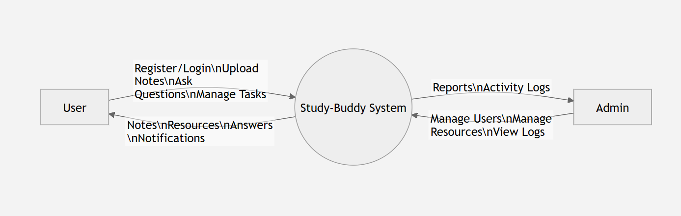

Figure 3.6.1: Context Diagram

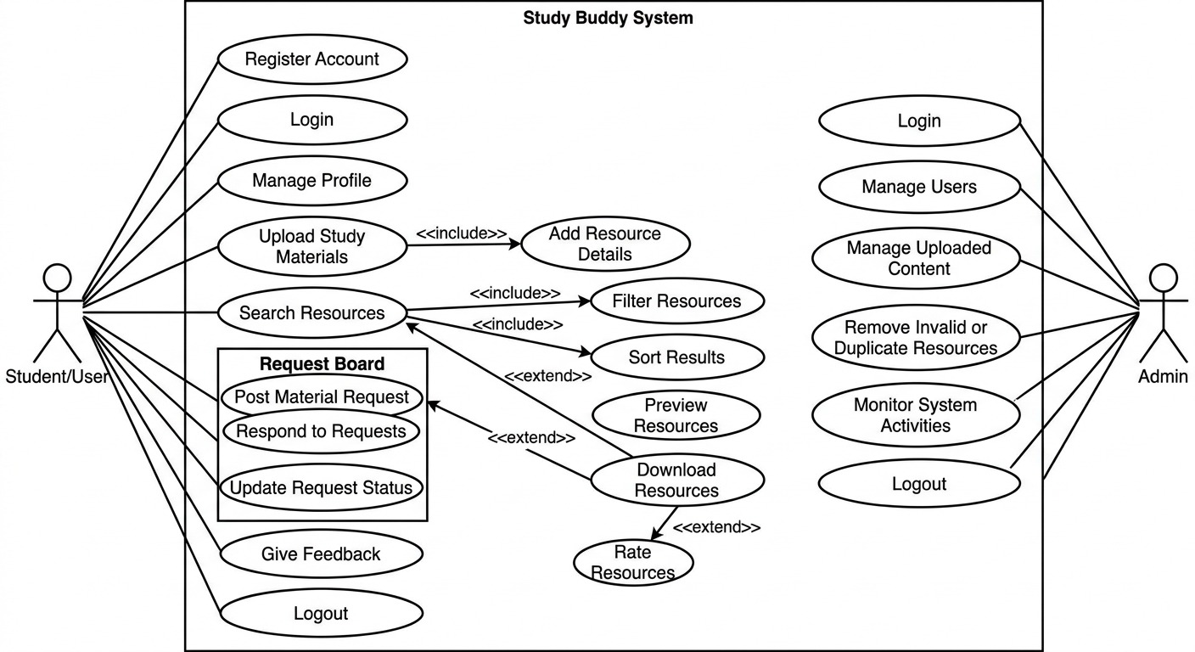
3.6.2 Use Case Diagram

3.6.3 Entity-Relationship (ER) Diagram

Figure 3.6.2: Use Case Diagram

3.6.3 Entity-Relationship (ER) Diagram
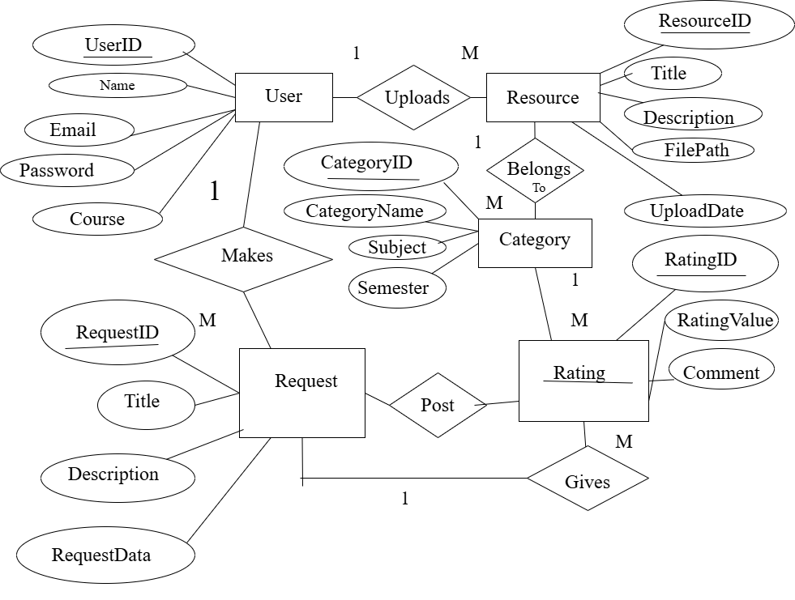
Figure 3.6.3: ER Diagram

4. Design

4.1 Introduction
The design phase translates the functional and non-functional requirements into a structured blueprint for developing the Study-Buddy application. A well-planned design ensures that the system is modular, maintainable, scalable, and easy to understand. Study-Buddy follows the Model-View-Controller (MVC) architecture, separating the user interface, business logic, and database operations into different layers. This separation improves code reusability, maintainability, and simplifies future enhancements.
The application consists of JavaFX-based user interfaces, Java controllers for business logic, DAO classes for database operations, and Microsoft SQL Server as the backend database.

4.2 System Design
Study-Buddy adopts the MVC (Model-View-Controller) architectural pattern.
Model Layer
The Model layer contains entity classes representing database objects such as:
- User
- Note
- Request
- Category
- Comment
- Admin
These classes encapsulate application data and communicate with DAO classes.
View Layer
The View layer is implemented using JavaFX FXML files.
Major interfaces include
- Login Screen
- Registration Screen
- Dashboard
- Task management
- Upload Notes
- Notes Viewer
- Request Board
- User Profile
- Admin Dashboard
- Category Management
The interface was designed to be simple, responsive, and user-friendly.
Controller Layer
The Controller layer handles all business operations.
Examples include:
- LoginController
- RegisterController
- DashboardController
- NotesController
- RequestController
- AdminController
- NotificationController
Controllers receive user input, validate data, communicate with DAO classes, and update the user interface.

4.3 Database Design
Study-Buddy uses Microsoft SQL Server as the relational database management system.
The database stores user information, uploaded study materials, requests, comments, categories, and administrative records.

4.3.1 User Table
Table 4.3.1: User Table
Field | Data Type | Description
user_id | INT | Primary Key
full_name | VARCHAR(100) | User Name
Email | VARCHAR(100) | Email
Password | VARCHAR(100) | Password
Role | VARCHAR(100) | Student/Admin
created_at | DATETIME | Registration Date

4.3.2 Notes Table
Table 4.3.2: Notes Table
Field | Data Type | Description
note_id | INT | Primary Key
Title | VARCHAR(200) | Note Title
Description | TEXT | Description
subject | VARCHAR(200) | Subject
category_id | INT | Foreign Key
uploaded_by | INT | User ID
file_path | VARCHAR(255) | Stored File
upload date | DATETIME | Upload Date

4.3.3 Request Board (Ask QN) Table
Table 4.3.3: Request Board Table
Field | Data Type | Description
request_id | INT | Primary Key
Title | VARCHAR(150) | Request Title
Description | TEXT | Description
requested_by | INT | User
Status | VARCHAR(20) | Fulfilled
created_date | DATETIME | Date

4.3.4 Category Table
Table 4.3.4: Category Table
Field | Data Type
answer_id | INT
note_id | INT

4.4 Interface Design
The interface was designed following usability principles.
Design Objectives
- Simple navigation
- Consistent layouts
- Fast accessibility
- Responsive JavaFX interface
Login Screen
The login page allows users to
- Enter email
- Enter password
- Login
- Navigate to registration
Dashboard
The dashboard displays
- Welcome message
- Search bar
- Latest resources
- Categories
- Navigation menu
Upload Notes Screen
Allows students to
- Select file
- Enter title
- Select subject
- Select category
- Upload
Request Board
Allows users to
- Post requests
- Browse requests
- Update status
- View fulfilled requests
Admin Dashboard
Admin can
- Manage users
- Manage notes
- Manage categories
- View reports
- Remove inappropriate resources

4.5 Summary
The Study-Buddy design follows a modular MVC architecture that separates presentation, business logic, and database access. The relational database ensures data consistency through primary and foreign key relationships, while the JavaFX interface provides a simple and intuitive user experience. These design decisions improve maintainability, scalability, and ease of future development.

5. IMPLEMENTATION AND TESTING

5.1. Implementation Approaches
Study-Buddy was developed using Java, JavaFX, JDBC, and Microsoft SQL Server
Technologies used:
Table 5.1: Technologies used while Implementation
Technology | Purpose
Java | Core Programming
JavaFX | GUI Development
FXML | Interface Design
CSS | Styling
JDBC | Database Connectivity
SQL Server | Database
IntelliJ IDEA | IDE
Git | Version Control

5.2 Coding Details
The project consists of several packages.
- Controller
- Dao
- Model
- Service
- Util
- View resources
- Database
Login Module Responsibilities
- Validate user input
- Authenticate credentials
- Redirect based on role
Registration Module Functions
- Validate email
- Check duplicate account
- Save new user
- Encrypt password (if implemented)
Upload Module allows users to
- Browse files
- Validate file
- Upload
- Store data
- Save file path
Search Module implements
- Keyword searching
- Subject filtering
- Category filtering
Request Board Module features
- Add Request
- Edit Request
- Delete Request
- Mark Completed
Admin Module performs
- User Management
- Category Management
- Resource Approval
- Delete Resources

5.2.1 Code Efficiency
The project follows good programming practices.
Techniques Used
- MVC Architecture
- Reusable DAO classes
- Prepared Statements
- Exception Handling
- Modular methods
- Connection reuse
- Input validation
- Object-Oriented Programming
Prepared Statements reduce SQL injection risks while improving query execution.

5.3 Testing Approach
Testing was conducted throughout development.
Testing types included
- Unit Testing
- Integration Testing
- System Testing
- User Acceptance Testing

5.3.1 Unit Testing
Each module was tested individually.
Examples
- Login validation
- Registration
- Upload notes
- Search
- Delete note
- Achievement points
All modules produced expected results.

5.3.2 Integrated Testing
Table 5.3.2. 1:Integrated Testing
Test ID | Modules Integrated | Expected Result | Actual Result | Status
IT-01 | Login → Dashboard | Dashboard opens after login | Successful | Pass
IT-02 | Registration → Login | New user can log in | Successful | Pass
IT-03 | Upload Notes → Database → Dashboard | Uploaded note displayed | Successful | Pass
IT-04 | Search → Database | Matching notes retrieved | Successful | Pass
IT-05 | Request Board → Database | Request saved and displayed | Successful | Pass
IT-06 | Category → Upload Notes | New category available | Successful | Pass
IT-07 | Admin Delete → Database | Note deleted successfully | Successful | Pass
IT-08 | Logout → Login | User returned to Login screen | Successful | Pass

5.3.3 Beta Testing
Prior to final deployment, a Beta Testing phase was conducted over three days. A localized instance of the software was provided to five BCA students and one faculty member. They were tasked with performing standard operations (registering, searching, checking out) to identify any UI/UX friction points or unexpected edge-case errors that the development team missed.

5.4 Modifications and Improvements

Table 5.4. 1:Modifications
Initial Design | Final Implementation
Simple Login | Role-Based Login
Basic Search | Subject Filter
Notes Only | Request Board
Basic Dashboard | Statistic Panel

5.5 Test Cases
Table 5.5. 1: Test Cases
Test Case ID | Feature/Module | Test Description | Expected Result | Status
TC- 01 | User Registration | Register a new user with valid name, email, password, and course details. | Account created successfully; record added securely to the MS SQL database with encrypted password. | Pass
TC- 02 | User Registration | Register a user using an already existing/registered email address. | System displays an error message: "Email already registered." Account creation rejected. | Pass
TC- 03 | User Login | Authenticate a user with valid credentials | Login successful; user session starts, and dashboard interface opens successfully after authentication. | Pass
TC- 04 | User Login | Authenticate a user with an incorrect password or unregistered email. | Login fails; system displays an error: "Invalid email or password." | Pass
TC- 05 | Resource Upload | Upload a study resource (e.g., PDF notes) with valid subject, course, and semester fields. | File uploaded successfully and stored in the database. | Pass
TC- 06 | Resource Upload | Attempt to upload a resource without entering mandatory fields (e.g., missing Subject Name). | System prevents upload and shows validation warning: "Please fill in all mandatory fields." | Pass
TC- 07 | Search & Filter | Search for a specific resource using a keyword (e.g., "Java") and filter by 4th Semester. | The interface displays only the records matching "Java" under the selected semester. | Pass
TC- 08 | Request Board | Post a new request with a clear subject description. | Uploaded resource is linked to the request and becomes available to users. | Pass
TC- 09 | Request Board Interaction | Respond to an active student request by uploading the requested material. | File links to the specific request ID; the requester gets updated and the resource status updates. | Pass
TC- 10 | Request Interaction | Add a reward an uploaded study note. | Rating and comments are stored successfully and displayed. | Pass
TC- 11 | Admin Management | Admin deletes a duplicate file or unauthorized/invalid academic resource | Resource is removed from the system and no longer appears in search results. | Pass
TC- 12 | Logout | User clicks on the "Logout" button. | User session ends and the Login page is displayed. | Pass
TC- 13 | Edit Profile | Modify user profile details such as name or course details from the profile dashboard. | Changes saved successfully; user profile data updates in MS SQL Server and reflects instantly on UI. | Pass
TC- 14 | Download Resource | Click the download button on an available resource. | The file downloads successfully to the local desktop environment. | Pass
TC- 15 | Delete Own Resource | A student attempts to delete a file that they personally uploaded to the system. | The resource is successfully removed from the system and record updates in database | Pass
TC- 16 | Search with No Result | Search using an invalid keyword or combination that doesn't match any system records. | System returns zero items and safely displays "No resources found" notice. | Pass
TC- 17 | Admin Login | Securely log into the application using system administrator credentials. | Admin authentication passes, opens dedicated panel with user and content control tools. | Pass
TC- 18 | Invalid File Type Upload | Attempt to upload an unauthorized system file type instead of a valid study format. | Upload is rejected, system displays warning: "Invalid file format. Only PDF,PPT files”. | Pass

5.6 Verification and Validation
The verification and validation processes for the Study-Buddy are essential ensure that it is built correctly and meets user expectations. By systematically reviewing requirements, conducting through testing and involving users in the validation process, developers can deliver a high-quality experience (GeeksforGeeks, 2025).
Verification:
Verification ensured that the software was built according to the specified requirements through:
- Code reviews
- Database verification
- Input validation checks
- SQL query testing
- User interface inspection
Validation:
Validation confirmed that the completed system satisfied user needs through:
- Functional testing of all modules
- User acceptance testing with students
- Performance evaluation for search and upload operations
- Database consistency checks
The successful execution of all major test cases demonstrated that the Study-Buddy system met its functional objectives and operated reliably within the defined project scope.

6. RESULTS AND DISCUSSION

6.1 Test Reports
The Study-Buddy application is successfully developed and tested according to the system requirements specified in earlier chapters. The testing process included unit testing, integration testing, system testing, and user acceptance testing to ensure that every module functioned correctly both individually and as part of the complete system.
The application is executed on a Windows 11 operating system using Java Development Kit (JDK 26), JavaFX SDK, IntelliJ IDEA, and Microsoft SQL Server. All core functionalities operated successfully with stable communication between the JavaFX user interface and the SQL Server database through JDBC
. The major functionalities that were tested are listed below.
Table 6.1 1: Modules and their Status
Module | Status
Login | Pass
Registration | Pass
Dashboard | Pass
Upload Notes | Pass
Search Resources | Pass
Request Board | Pass
Categories | Pass
Comments | Pass
Admin Panel | Pass
Database Connectivity | Pass

6.2 User Documentation
This section provides a brief guide for end users to operate the Study-Buddy application.
Step 1: Launch the Application
Run the application using IntelliJ IDEA or the generated executable file.
The Login window will appear.
Step 2: Register a New Account
If you are a new user:
- Click Register
- Enter:
- Full Name
- Email
- Password
- Confirm Password
- Click Create Account
The system validates all information before saving the account.
Step 3: Login
Enter your registered email and password.
Click Login.
The system verifies the credentials and redirects users to their respective dashboard based on their role.
Step 4: Dashboard
After successful login, users can:
- View uploaded resources
- Search study materials
- Browse categories
- Open Request Board (Ask Question)
- Access profile
- Logout
Step 5: Upload Study Materials
- Open Upload Notes
- Select Category
- Enter Title
- Enter Description
- Choose File
- Click Upload
The uploaded resource becomes available to other users.
Step 6: Search Resources
Users can:
- Search by title
- Search by subject
- Filter by category
Matching resources are displayed immediately.
Step 7: Request Board (Ask Question)
Users can:
- Create new requests
- View existing requests
- Update request status
- Browse fulfilled requests
Step 8: Administrator Functions
The administrator can:
- Manage users
- Manage categories
- Remove inappropriate resources
- View uploaded notes
- Monitor system activities
Step 9: Logout
Click the Logout button to safely terminate the current session.
The application redirects the user back to the Login page.

7. Conclusion

7.1. Conclusion
The Study-Buddy project is successfully designed, implemented, and tested as a desktop-based academic resource sharing application. The project addressed the common difficulties students experience when searching for lecture notes, assignments, past examination papers, and other academic materials.
The application provides a centralized platform where students can upload, search, download, and request study resources efficiently. The implementation of secure user authentication, organized categorization, powerful search functionality, and a collaborative Request Board has significantly improved the accessibility and management of academic resources.
The system is developed using Java, JavaFX, JDBC, and Microsoft SQL Server, following the MVC architectural pattern. This architecture enhanced code maintainability, reduced redundancy, and simplified future development.
Comprehensive testing demonstrated that all major modules—including user authentication, resource management, request handling, category management, administrative functions, and database operations—performed successfully without critical errors. Integration between the graphical user interface and the database remained stable throughout the testing process.
Overall, the Study-Buddy system successfully fulfilled the objectives established at the beginning of the project and provides a practical solution for improving academic resource sharing within educational institutions.

7.2. Significance of the System
The Study-Buddy application provides several important benefits for educational institutions and students.
The major contributions include:
- Centralized management of academic resources
- Improved collaboration among students
- Reduced dependency on social media for resource sharing
- Faster searching and retrieval of study materials
- Organized categorization of educational resources
- Simple and user-friendly desktop interface
- Better management through administrative controls
The application enhances learning by encouraging knowledge sharing and improving access to educational resources in an organized environment.

7.3 Limitations of the System
Although the application satisfies the primary project objectives, several limitations remain.
- The system is currently available only as a desktop application.
- Internet-based synchronization is not supported.
- Real-time messaging between users is unavailable.
- File preview functionality supports only limited document types.
- Password recovery through email has not yet been implemented.
- Push notifications are not available.
- Cloud storage integration has not been implemented.
Despite these limitations, the system performs effectively within the defined project scope.

7.4 Future Scope
The modular architecture of the Study-Buddy application allows numerous future enhancements.
Future improvements may include:
- Real-time messaging between students
- Video-based collaborative study sessions
- Email verification and password recovery
- QR-code-based resource sharing
- Notification system using email and SMS
- Recommendation engine based on user interests
These enhancements would improve usability, accessibility, and collaboration while expanding the system for deployment in larger educational institutions.

8. Reference
(2023). Retrieved May 2, 2026, from www.sakailms.org: https://www.sakailms.org/sakaiplus
(2024, October 1). Retrieved May 1, 2026, from www.openolat.com: https://docs.openolat.org/manual_user/about/Information_on_OpenOlat/
Wikipedia Foundation Inc. (14, February 2026). Retrieved May 1, 2026, from www,wikipedia.org: https://en.wikipedia.org/wiki/OpenOLAT

